Movie Landing Page Website Design

Name: Dhulipalla vasanth

Mail Id : vasanthdhulipalla2002@gmail.com

Phn No : 9704076150

Roll N0 : 20HU1A0550

College Name : Chebrolu engineering college

**Source Code:**

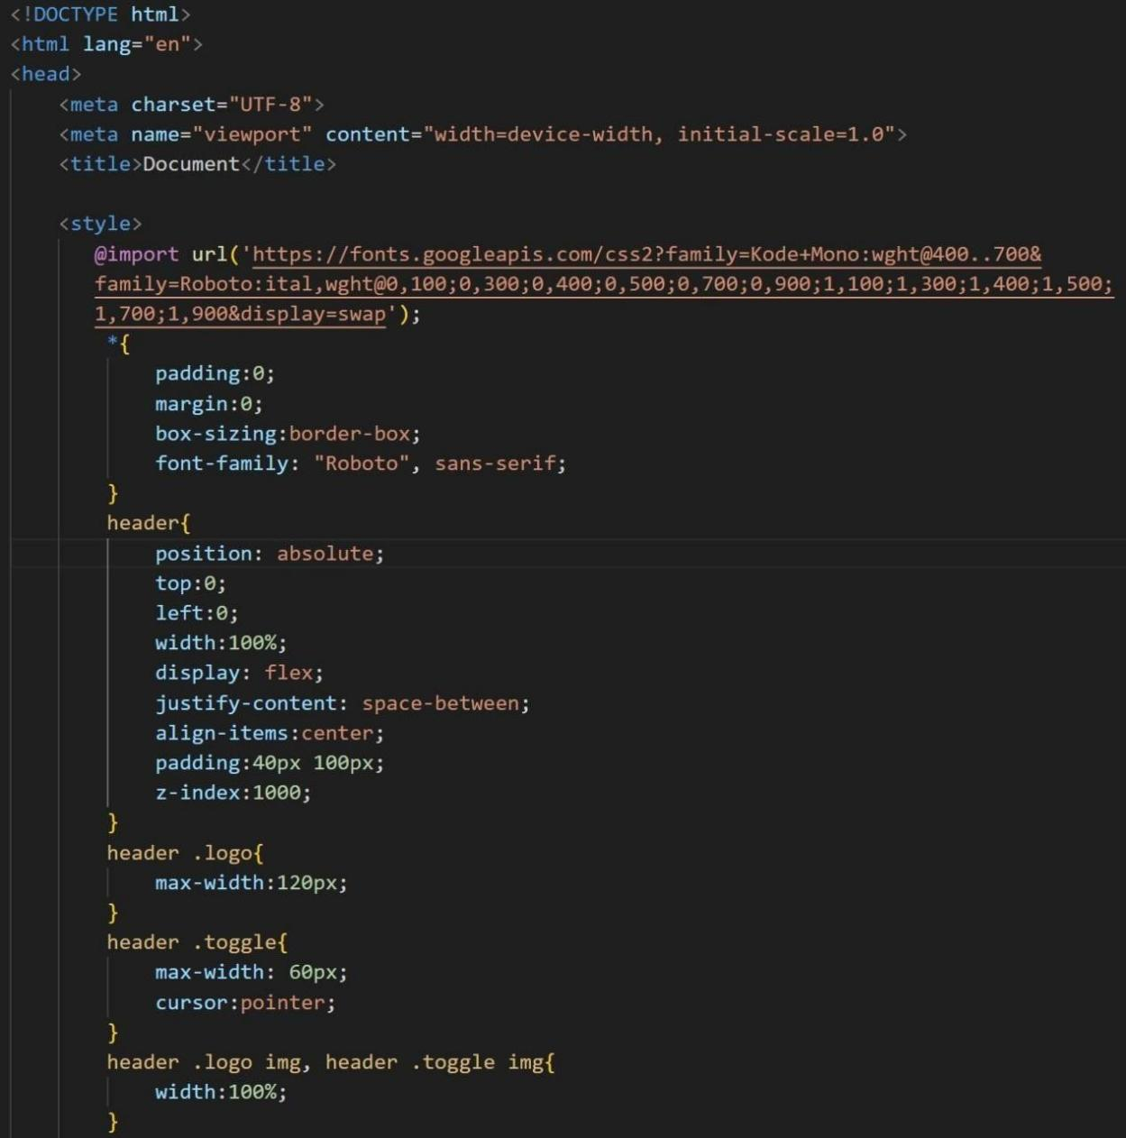

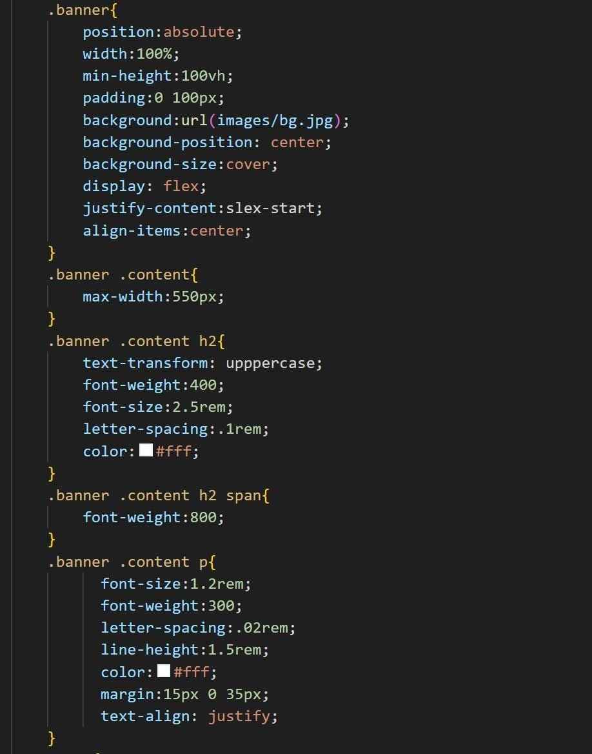

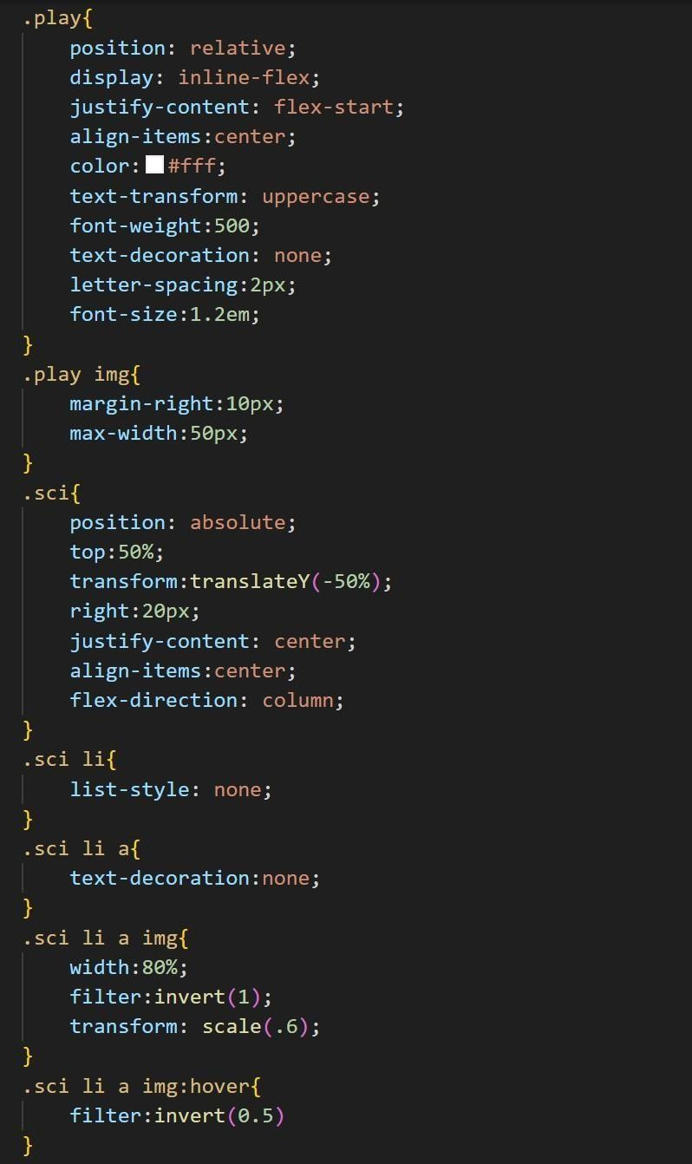

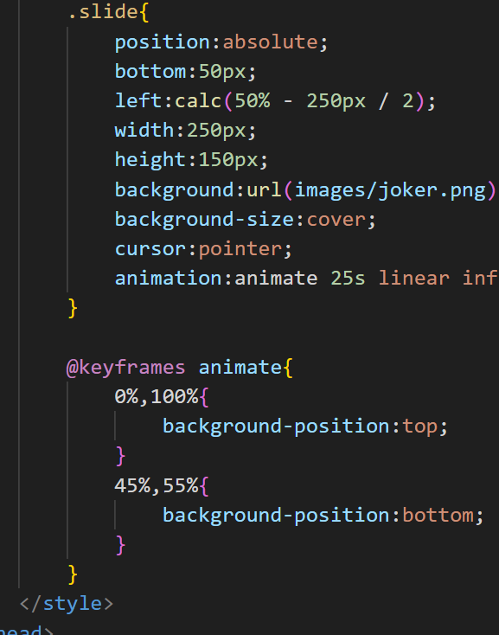

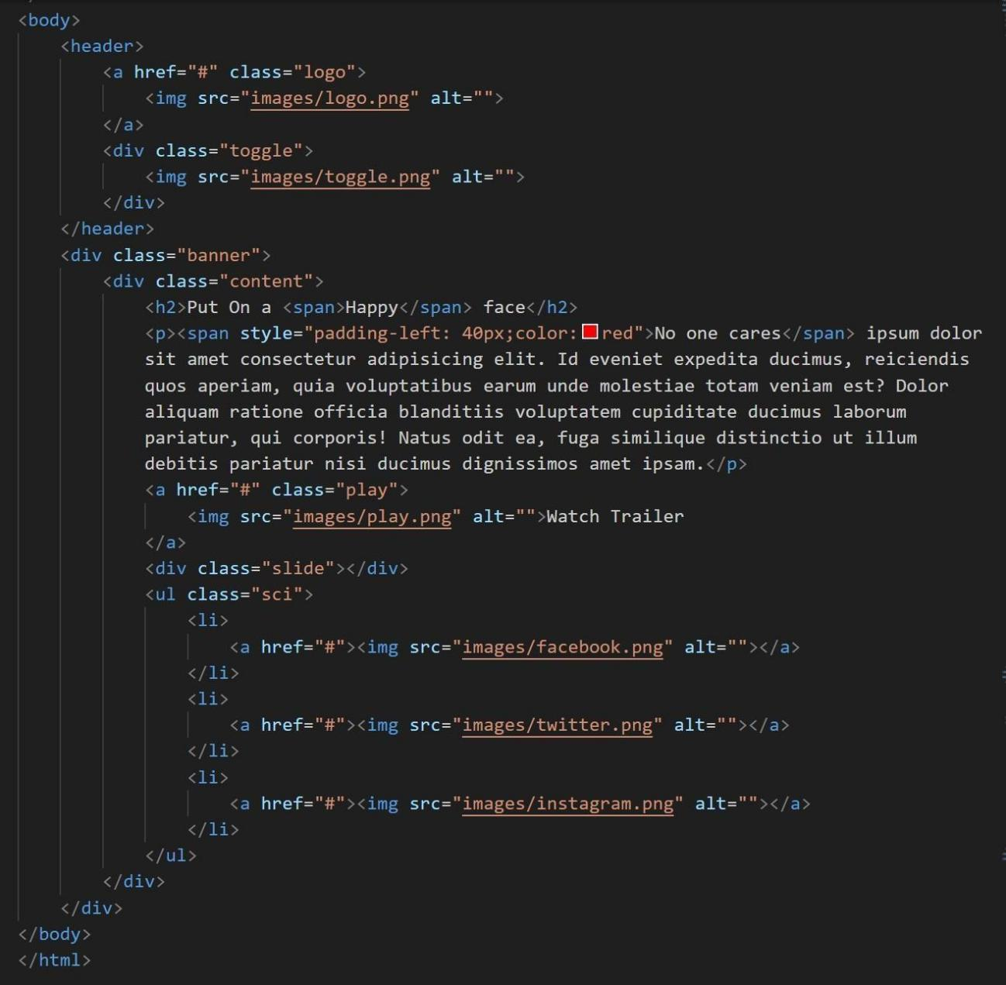



**Output :**